2021 Scout Leader’s

Guide to Recruitment

Buffalo Trace Council, BSA

Dear Scout Leaders,
Thank you for providing a fun program for youth that builds character, improves physical fitness, teaches practical skills, and develops a spirit of community service. Because of the time and effort you and other parents put forth, youth in your pack will have advantages in life they may not otherwise have had. Every child deserves the chance to experience the Scouting program and it all starts with giving every child the opportunity to join.
This guide provides the tools needed to develop and implement a successful plan to invite all kids in your area to join your pack or troop.
If you need assistance or have other questions about recruitment, please contact your district executive. Additional tools and resources to help you with recruitment can be found at https://www.buffalotracecouncil.org/cub-scouting.

Lincoln Heritage District Associate

Algonkian District Executive

Chris Felton

Grant Burnett

(812) 423-5246 ext. 2216

(812) 423-5246 ext. 2217

Grant.burnett@scouting.org

christopher.felton@scouting.org
Native Trails District Director

Abby Roberts

(812) 423-5246 ext. 2214

Abigail.roberts@scouting.org

Membership Specialist

Jennifer Carapia

(812) 423-5246 ext. 2201

Jennifer.Carapia@scouting.org

Have Questions? Need Help? Contact:
Table of Contents
Timeline For Success 4
Promoting Your Unit: The Rule of 12 5
Promotion Effort 6
Promotion Timeline 7
School Talks 8
Join Night Checklist 9
Join Night Format 10
Join Night Stations 11
Orientation for New Families 12
October Recruitment Plan 13
Youth Application Requirements 14
Adult Leader Registration 15

Timeline for Success
Begin planning early with input and help from all leaders to ensure a successful recruitment. See page 7 for a specific timeline for promotion.

June/ July
- Attend Council Membership Training to learn more about how to market your Pack and learn more about fall recruitment.
- Hold a unit/parent committee meeting to discuss all aspects of a successful recruitment and assign responsibilities to parents and leaders.
- Contact the school(s) your unit serves to reserve a room for the Scout join night. Contact through email.
- Coordinate additional promotion efforts to ensure every youth receives at least 12 invitations to join Scouting. Follow through. See list of possible methods on page 5. Council will provide Social Media posts.
- Arrange to have an information booth at your school’s open house night, student supply drop off, or other parent information meeting to promote your pack.

August/Early September
- Attend August Roundtable in your district and receive your pack’s 2021 Scout recruitment kit.
- Confirm the school will be unlocked and ready for your join night.
- Conduct the Join Scouting Night! See instructions on pages 9-11.
- Submit join night report envelope (including rosters, applications, and fees) to your district turn-in site.
- Within 24-48 hours of join night email or call each new family to thank them for joining your unit and answer any questions.
- Hold an orientation for new families within one week of join night. A sample agenda can be found on page 10.

September
- Be sure each new adult leader completes youth protection training and basic training for their position (available online at my.scouting.org).
- Submit new leader applications. See page 15 for adult registration process.

October
- Ensure all dens are meeting regularly, if you are a Cub Scout pack.
- Distribute flyers at school to reach any youth who may have missed your Join Scouting Night. Flyers should read “It’s not too late to join Scouting!” and invite them to your October pack/troop meeting or other activity. Be sure flyers are distributed one week before the meeting.
- Be prepared at the October meeting to enroll new youth into your unit and assign to the appropriate dens if applicable.

Promoting Your Unit: 12 Step Membership Plan
Research has shown that people need to be invited to do something an average of 12 times before they are likely to act. How does that apply to Scout recruitment? It’s important that families are invited to your Join Scouting Night at least 12 times. The Council offers a variety of prepared materials to assist in this effort, and the methods below have a proven record of yielding best results.

Best Methods (At A Minimum, Your Unit Should Do These)

1. Open House Display
Set up a booth at your school’s open house, supply drop off, or other parent informational meeting to promote your unit. See page 6 for examples of eye-catching displays. Be sure to have an interest form to collect parent contact information.

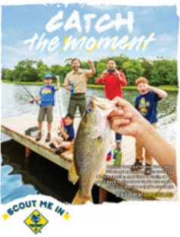
2. Yard Signs
Get the word out in the community by placing yard signs in high-traffic areas and in front of school. In large block letters, clearly write the date, time, and location of your JSN on the yard sign. Tip: place yard signs only at high traffic stop areas so each car that stops will be able to see it. Drivers will not be able to read yard signs while driving.

3. Back to School Flyers
Send an invitation home with every youth at school to be sure parents are

aware of your JSN. If your schools do not allow flyers, perhaps a postcard can be mailed directly to students. Contact your district executive to coordinate this.

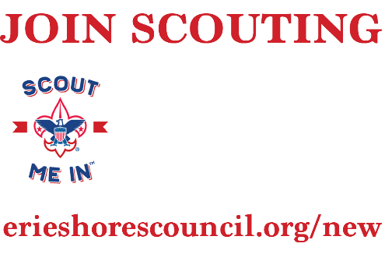
4. School Talk with Flyers/Stickers
A great way to ask students to join Scouting is by visiting their school and generating excitement about all the fun activities and events your unit participates in. School talk day is a great day for all current Scouts to wear their uniform to school. Contact your district professional to coordinate flyers and school talks. See page 8 for more information about school talks.
If not able to use Facebook, write a small article to be published in advance of your JSN if you have a small-town newspaper, radio station, local church bulletin accessible to your unit. Your District Professional can help if needed.
5B. Press Release/Church Bulletins
Geofencing is a method of geographically targeting a specific audience using Facebook. We encourage your unit to set up an event in Facebook to feature a “Join Scouting” night for each unit. You will put a “geofence” around the neighborhood area to reach prospective families, serving as a social media ad. Target with zip code and number of miles.
5A. Facebook Events and Geofencing

Unit Promotion Effort
Ensure that every child is invited to join Scouting at least 12 times by selecting at least seven methods or more from the list below or other creative ideas to accompany the five best methods listed on page 5.

Great Promotion Ideas
- Telephone calls to perspective families; especially Lions and Tigers, and new Scouts BSA youth
- Social media blitz, and Facebook Geofencing
- Create Pack sign up information posters and get permission to put them up in high traffic areas
- Current Scouts wear their uniform on the day of the School Talk and/or Join Night
- Bookmarks delivered to local libraries
- Display cases and bulletin boards at schools, libraries, etc.
- Community newsletters, community bulletin board posts, and website posts
- Classroom, lunchroom, and Sunday school visits
- Displays at local supportive businesses; Text on business marquees advertising the information to join
- Pack special events in the community (fishing derby, picnic, parade, fair, etc.)
- Pack information sheets in grocery store bags
- Hold a pinewood derby at a visible location in your area
- Parent-to-parent recruiting; parents tell of impact Scouts for their families and encourage to join
- Peer-to-peer recruiting: Current Scouts give personal invitation to friends
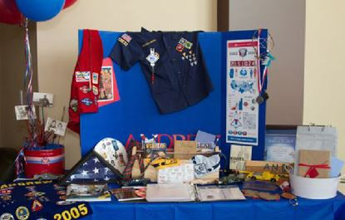
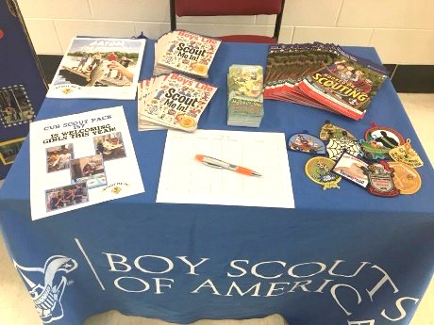
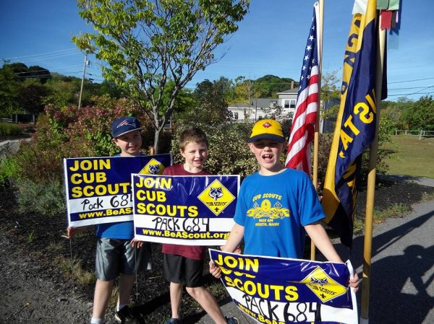
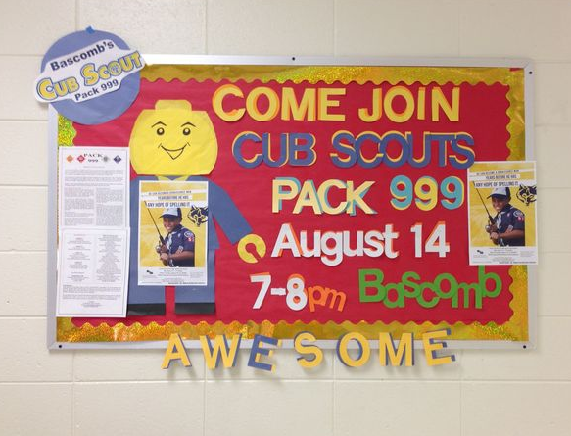
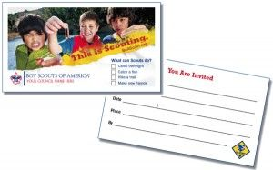
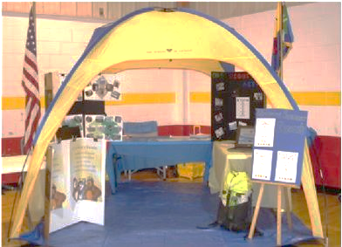
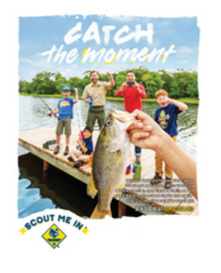

Planning Timeline
The key to a great promotion campaign is preparation. The checklist below shows the ideal dates to execute the best methods on page 5.

Prepare in advance
- Meet with your Pack and set the calendar for 2021-2022

- Schedule New Parent Orientation sometime in the week after Sign-Up Night.

- Find out open house and kindergarten orientation dates. Arrange for a representative from your Pack to be there to host a table. It will likely be held prior to our council sign up dates.

- Contact your school to make sure they have Scout sign up night in the calendar and are prepared to have a door open for you on your assigned day. (Arrive early to set up your table)

- Plan to have at least two-unit representatives attend each of your recruitment sites. Arrange for all Den Leaders and committee members to help with orientation.

- If the school allows, encourage your current Scouts to wear their uniform to school the day before or day of your sign-up night.

- Make sure your BeAScout pin and unit online registration is updated and ready. For assistance with this, contact your District Professional.

Prepare for night of the event
- Make sure you bring your Pack calendar to the Sign-Up Night. Have copies for all new families. Highlight your NEXT MEETING.

- Make sure you bring copies of your contact list of all Pack leadership for new families, so they know who to call with questions, how to sign up for the unit Facebook page, website, etc.

- Bring CHANGE to your Sign-Up night (recommended $50 in $5 bills and $20-$25 in $1 bills)

- Have your Treasurer present with Pack checkbook or have a signed Pack check. (Families will write checks/pay cash to the unit. The unit can write one check to the Council for all fees, or may choose to write one for registration and Boys’ Life)
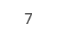
7

School Talks
A Cub Scout school talk is a three-to-five-minute presentation to kids during the school day to generate excitement about Scouting and tell them how they can join. School talks improve attendance at join nights dramatically. Do not miss this important step in the fall recruitment plan! A school talk is usually conducted by your district professional, but it’s always better to have a local leader at the school to talk about all the specific fun things that your Pack does. Contact your district professional to talk about accompanying them to the school talk. You can also provide a poster board with pictures about your unit’s yearly events.

Pack Leaders Helping with School Talks: Step by Step
Ideally, flyers will have been sent home with kids already and your visit will serve as a reminder of join night.
- Coordinate to arrive with your district professional about 15 minutes before the school talk.
- Stop at the school office to introduce yourself to the secretary and principal about 10 minutes prior to the time you have scheduled.
- The actual presentation to the students will be led by your District Professional, but should be prepared to offer:
  - A brief description of the fun activities the youth can do in Scouts in your Pack.
  - Repeat the date, time, and location of Join Scouting Night multiple times, and remind them that a parent needs to attend as well.
  - Help your District Professional make sure each child receives a flyer and/or sticker. Help each child put the sticker if allowed (teachers can help with this). Ask them to show the flyers/stickers to a parent as soon as they get home.

School Talk Sample Script

Hi, I’m (name), and I’m here to invite you to join Scouting! Scouts is a fun club for kids like you, and now is the perfect time to join!
I want to play a quick game with you to tell you about all the fun things you can do if you join Scouts. I am going to list an activity, and if you think it is fun, or think it would be cool to try, I want you to raise your hand as fast as you can. I want to see who the fastest hand raiser is in the whole class! Who thinks it would be fun to go hiking? Camping? (List activities that are special to your unit).
Our unit does all these things and if you join you can too! You can join by bringing your parents to our join night on (date, at time, at location). I am going to give you a flyer to remind you to tell your parents you want to join Scouts! Okay, just a reminder: what day is the sign-up night? What time? Where? Thank you for being good listeners! I hope to see you at our join night!

Join Night Checklist
Below are key items to plan for to ensure a successful Join Scouting Night.

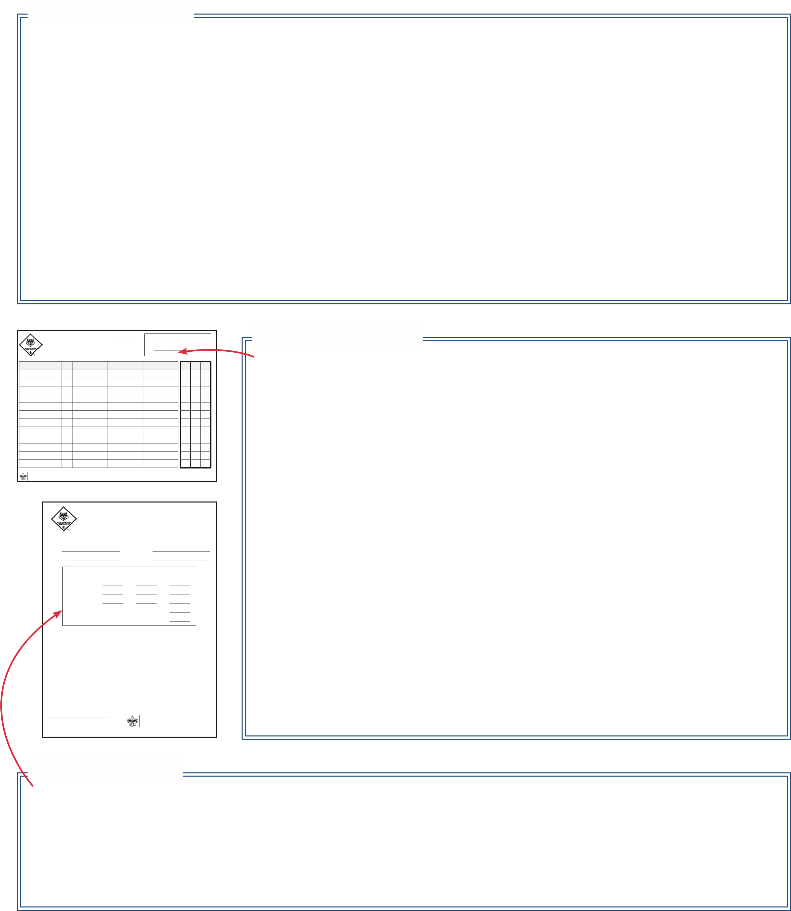
Before Join Night

Choose A Location
Your unit’s join night should be held at your local school(s) if possible. People want to feel comfortable and new families are usually unfamiliar with Scouting - give them the advantage of a familiar location. They are more apt to know where the library at school is than the Scout House or VFW Hall.

Select A Format
Decide how your join night will be structured. It is recommended that units utilize the five-station format (see page 10 for more details). Regardless of your structure, the evening needs to be organized and flow nicely for families, without too much information to overwhelm them.

Coordinate Uniforms
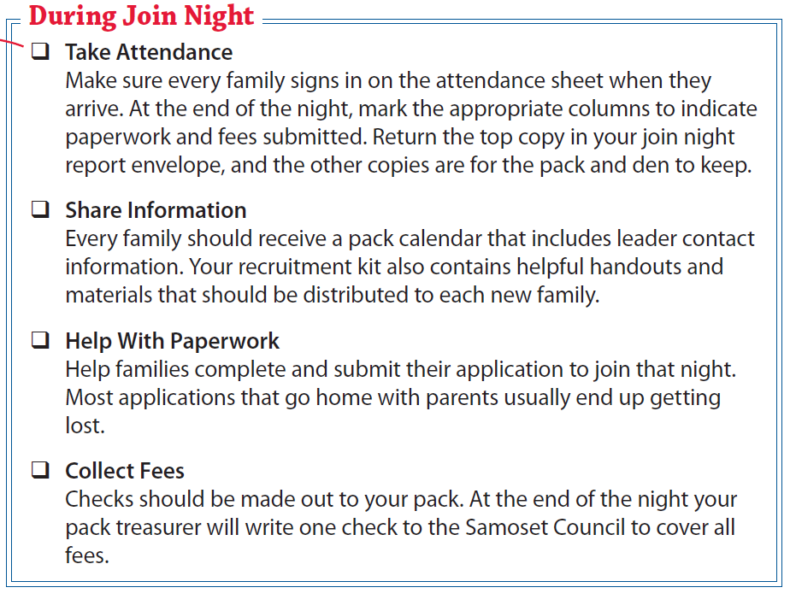
To make parents feel more comfortable, it is recommended that leaders wear a unit t-shirt with a name tag that identifies you as a “parent volunteer.” The BSA field uniform is always appropriate, but it can sometimes be intimidating to a new parent.

“BTC BSA” to cover fees.

Printed name

After Join Night

Submit Paperwork Place all paperwork and a check made out to “Buffalo Trace Council” in your join night report envelope and submit at your district turn-in location.
- Conduct a New Family Orientation Meeting
See page 12 for a sample agenda.
9

Join Night Format
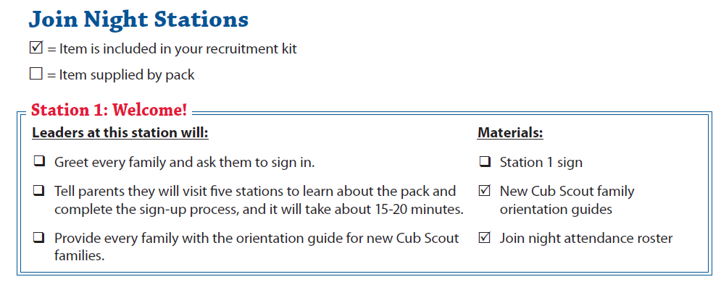
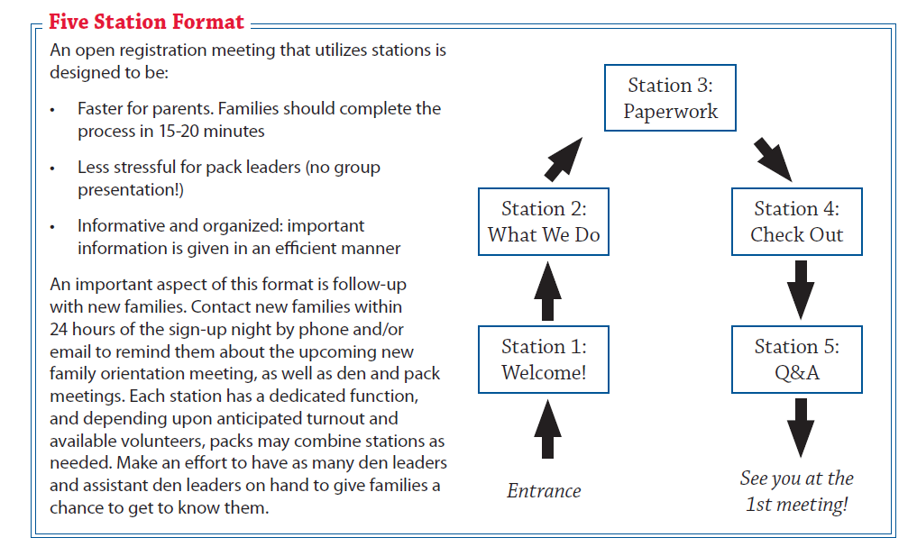
It is recommended that units structure their join night as an open registration meeting. This type of sign-up night allows parents to arrive throughout a scheduled block of time (6:30 to 7:30 PM) and flow through stations to get important information, register their child, and leave.

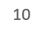
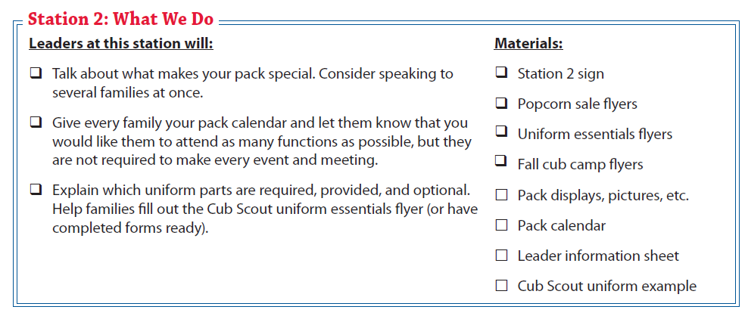
Review new Cub Scout family
orientation guide

Leader information sheet
Pack calendar
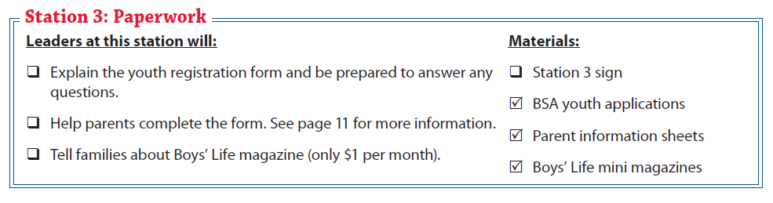

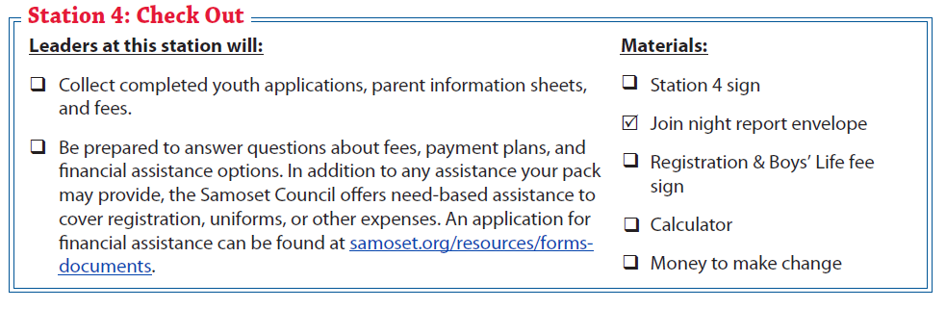
may provide, Buffalo Trace Council offers need-based assistance to cover registration, uniforms and camperships. Your District Professional can help you with forms if needed.

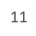
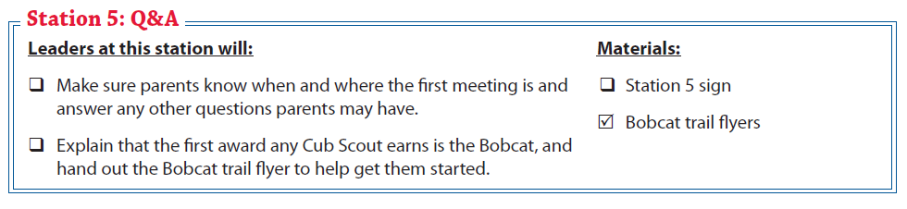
11

remind them of the date of the new Scout orientation.

Orientation for New Families
An orientation meeting for new families should be held no more than one week after the Join Scouting Night (JSN). All parents and leaders should attend.

Suggested Meeting Agenda

1. Welcome & Introductions

2. Unit Program
- Explain the difference between: unit meetings, den meetings (if applicable), and parent committee meetings
- Review unit calendar and highlight upcoming activities
- Handout & review requirements for Bobcat. Set a goal as a pack to present each new youth their Bobcat badge no later than the October pack meeting.

3. The Pack Committee
- Explain that the Scouting program is an all-volunteer organization. Your unit is successful because each parent volunteers in some way during the year to help out. Some people run the meetings. Some people take a “behind the scenes” role on the committee and help with planning, paperwork or other administrative type duties. Some parents are not available to help every month, so they volunteer for short term projects such as the pinewood derby, court of honors, etc.
- Talk about key unit leadership needs. It may be helpful to have a large poster showing the organization and current positions that are needed.
- Ask parents to complete the parent information sheet if they have not already done so.

4. Leader Training
- Explain that youth protection training is required for all registered leaders and is strongly recommended for all parents. Direct all leaders to the council website for youth protection training or plan to conduct youth protection training together as leaders using the presentation format.
- Direct new leaders to the appropriate basic leader training courses offered online.
- Den Program (Separate into Dens if you are a Cub Scout Pack)
• Dens that already have a den leader:
– Den leader discusses den-meeting dates, times and locations and recruits parents to assist with den meetings or serve on the pack committee.
- Newly formed dens without a den leader:
- Another pack leader will need to guide the discussion with parents. Explain that it may take a few meetings to identify a parent to lead the den and ask for their cooperation and patience.
- Discuss possible meeting dates, times and locations.
6. Closing
- This meeting should not be conducted at the join night or a regular unit meeting.
- This is a chance for your unit to establish expectations, communicate the program plan, and answer any questions before the first official meeting.
- Arrange to have a few experienced parents run an activity for any youth and siblings who attend so you will have the full attention of the parents without distractions.
- This meeting should last no more than one hour, but plan to stay late to answer additional questions.
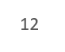
  - Think back to your first Cub Scout meeting - what do you wish you had been told?

October Recruitment Plan
The Join Scouting Night (JSN) is no doubt the single most productive recruiting event of the year for units. However, even when the promotion plan is executed perfectly some families miss the opportunity to join Scouting.
October unit meetings are the perfect opportunity to invite youth and their families to join your pack or troop that may have missed, or been unaware of, the JSN night. With very little additional effort, units across the council will bring hundreds of youth into Scouting this October that otherwise missed the opportunity to join in September.
There are only a few additional steps each unit needs to take in October to maximize the success of their fall recruitment.

October Recruitment Checklist
- Contact the school principal immediately after the Join Scouting Night (JSN) to thank them for their support of your unit’s successful recruitment event.
- As a Pack, plan your October follow-up date. Select location, date, time, volunteers to help and create a meeting agenda. Emphasize the importance of reaching out to families that may have missed the join night. Make sure to clearly communicate these plans with your District Professional at least 3 weeks before your date.
- If possible, your District Professional will deliver flyers to the school for distribution at least one week prior to your October meeting. The flyers must be ordered by contacting your District Professional.
- Be ready at your October meeting to welcome new families. Give new parents the information packet you used at your Join Scouting Night. Ask them to stay after the meeting for about 20 minutes so they can complete the paperwork and meet their den leaders (if applicable).
- Follow-up with all new families. Be sure they are aware of the meeting dates, unit activities, the popcorn sale, etc.
- Turn in paperwork and fees collected to register the new youth with your unit within 24-48 hours.
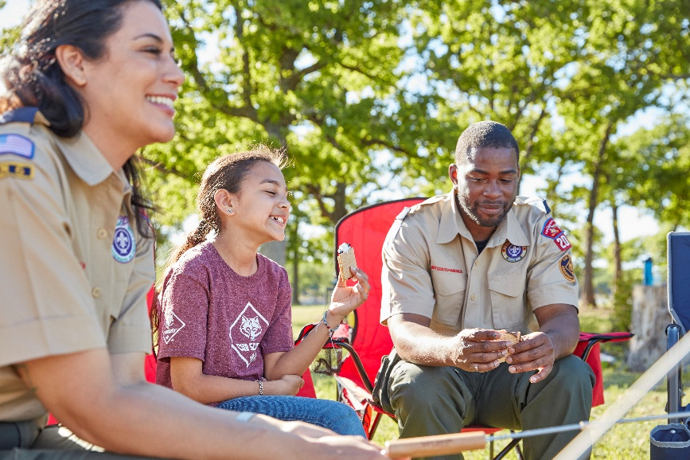

Youth Application Requirements
Ensure that youth applications are completed fully by parents before they leave the Join Scouting Night.
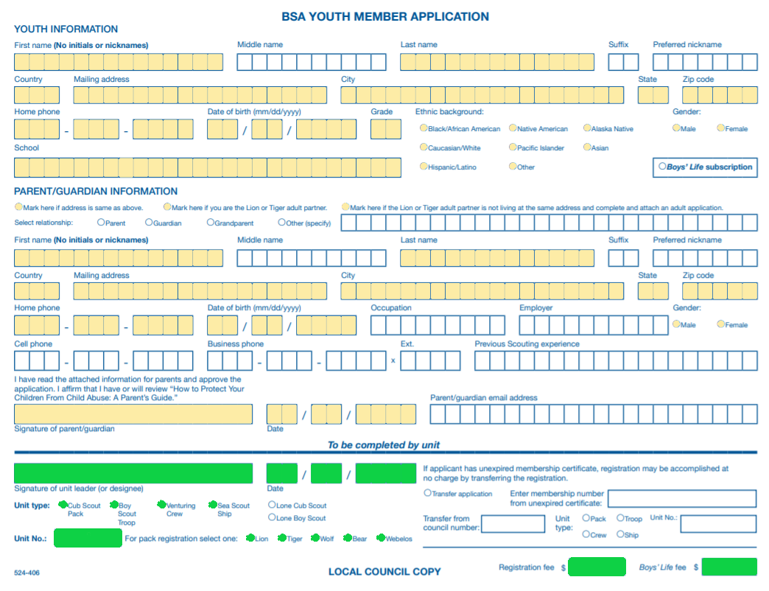
YELLOW highlighted fields need to be completed by a parent/guardian.
GREEN highlighted fields need to be completed by a unit leader.

Youth Fees for 2020
If recruiting in August 2020: Registration Fee $35.00; Boys’ Life fee $7.00.
If recruiting in September: Registration is $30.00; Boys’ Life is $6.00.
October recruitment is: Registration $25.00; Boys’ Life is $5.00.
November recruitment is: Registration $20.00; Boys’ Life is $4.00
December recruitment is: Registration $15.00; Boys’ Life is $3.00

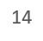

Adult Leader Registration
There are two pages of the adult application that need to be completed and turned in to the Council, along with verification of youth training, in order for an adult registration to be processed.
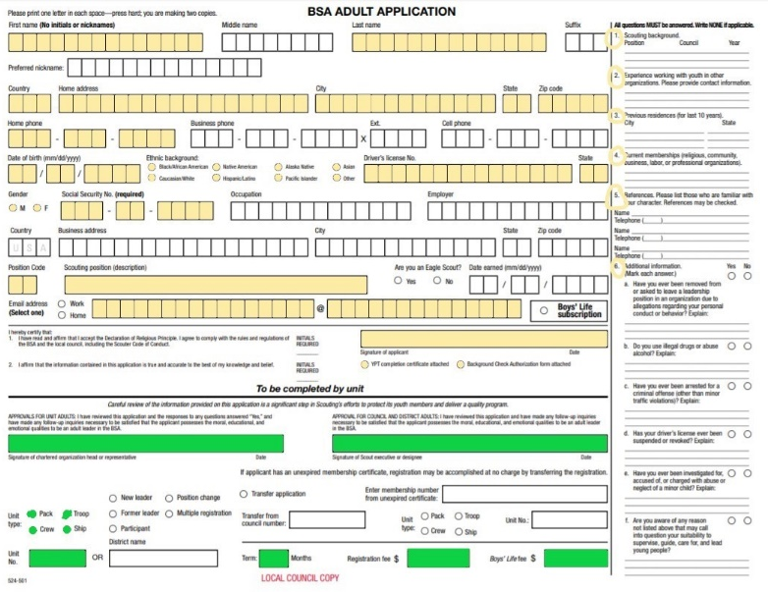
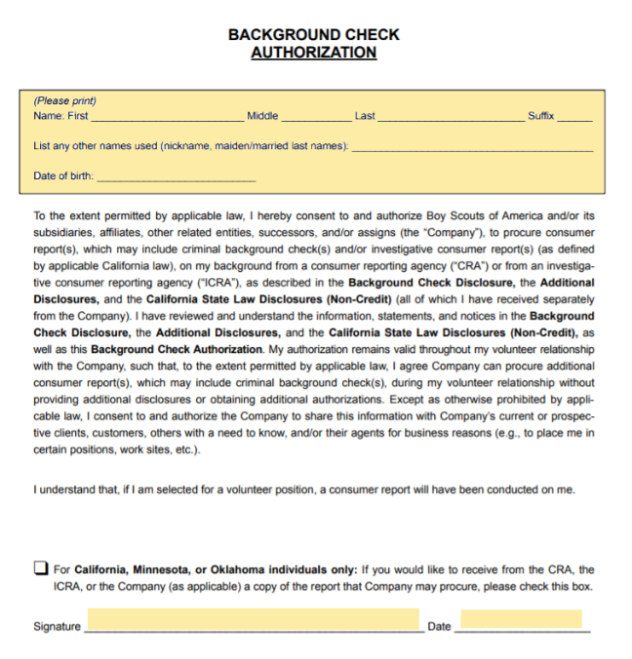
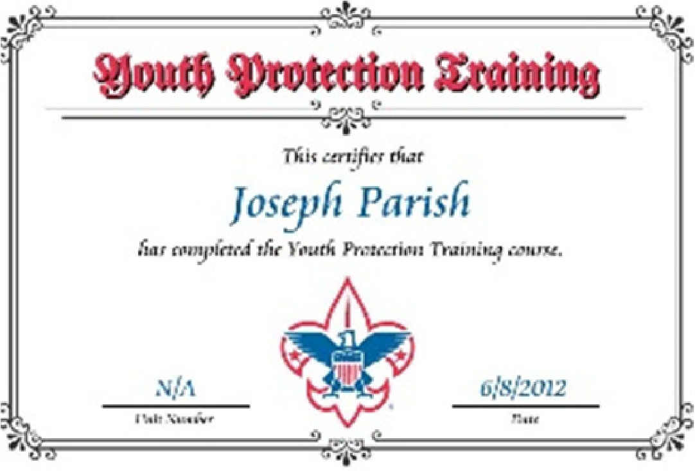
YELLOW
1
.
Applicant must fill out the adult application
entirely:
•
highlighted fields are required.
•
The authorization form must
be signed.
•
The
GREEN
highlighted portions require
the signature of the unit Committee
Chair and Chartered Organization
Representative.
2
.
Applicant must take BSA youth protection
training and submit a certificate of
completion.
•
To take training online:
a.
Go to
www.my.scouting.org
.
b.
Click on “Create an Account” and
follow the instructions to register as a
new member.
c.
After registering and logging in, click
on “BSA Learn Center” located along
the right margin.
d.
Take Youth Protection training. After
training is completed a certificate
will be issued, which will need to be
printed and included with the adult
application.
3
.
Submit the three pages (pictured here) to the
Council office for processing.

Buffalo Trace Council, BSA
3501 E Lloyd Expressway,
Evansville, IN 47715
Phone: (812) 423-5246
Fax: (419) 423-4845 www.buffalotracecouncil.org
